This is the title of the abstract (Times New Roman 14 bold)
First Author¹, Second Author², … (Times New Roman 11; presenting author underlined)
¹ Affiliation (Times New Roman 10 italic)
² Affiliation (Times New Roman 10 italic)
Text goes here. The entire abstract can have a maximum extension of 1 page. (Times New Roman 11).
Page size A4: 210x297 mm
You can add 1 Figure.

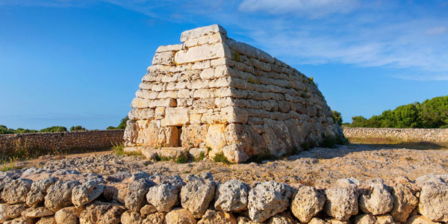

Figure 1: Figure’s caption (Times New Roman 10).

References
¹ N. Surname, et al., Journal vol, page (year).

